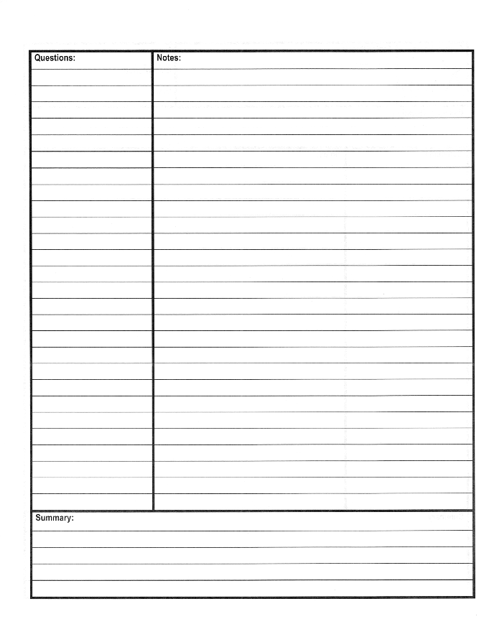

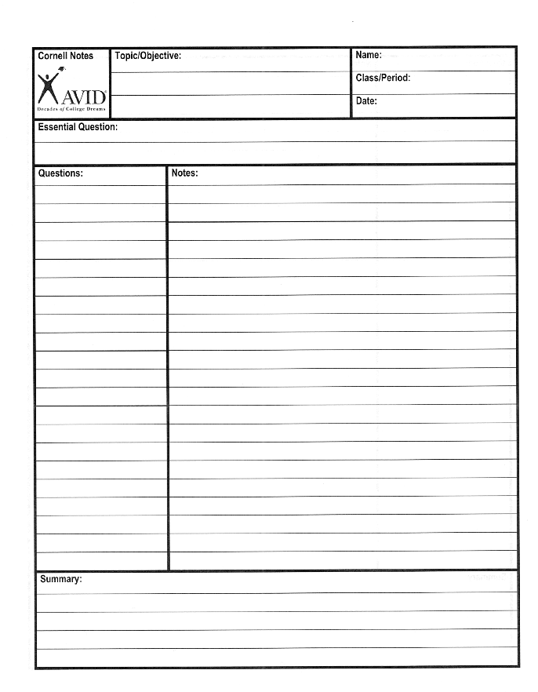

What is the importance of Deaf Jokes? What part do Deaf Frustrations in a hearing world and common experiences among the deaf play in Deaf Jokes? How does this book make you feel as a hearing person?

Deaf Culture Our Way