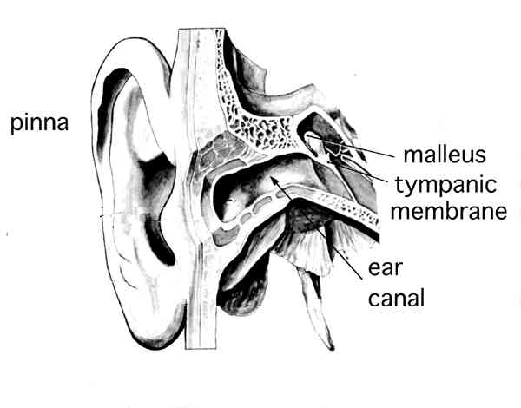
Outer Ear
The external ear consists of the outer portion of the ear that is visible on the side of the head, called the pinna, and the ear canal that leads to the tympanic membrane, also known as the ear drum. Its shape helps us localize where sounds in the environment are coming from. Sounds coming from the front are more easily directed into the ear canal.
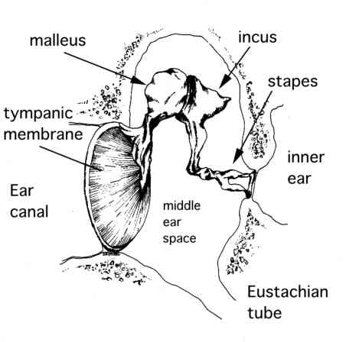
Middle Ear
The middle ear is that part of the ear between the external and the inner ear. Its outer border is the thin membrane known as the ear drum, or tympanic membrane.
The ear drum is a thin layer of tissue. As sound strikes the ear drum, it vibrates and in turn transmits these vibrations to the three small bones of the middle ear: the malleus, the incus, and the stapes.
The combination of the ear drum and the lever action of these bones helps to amplify the sound vibration. The end of the stapes is called the footplate and it is connected to the inner ear. As the stapes vibrates, the footplate moves in and out like a piston and transmits the sound vibrations into the inner ear.
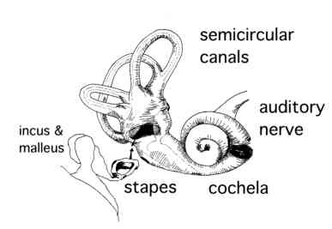
Inner Ear
The inner ear is the delicate structure which transforms the sound vibrations from the stapes into nerve signals that are transmitted to the brain. It also plays an important role in maintaining our balance. The inner ear consists of tiny fluid-filled canals encased in some of the hardest bone in the body.
The hearing portion of the inner ear is the cochlea, a snail shaped structure that is connected to the stapes. As the stapes moves in and out, it produces fluid waves within the cochlea. These waves in turn cause movement of tiny cells within the cochlea called the hair cells. As these hair cells vibrate, they send signals to the brain which can then be interpreted as sound.
Conductive Hearing Loss
Conductive hearing loss occurs when sound is not conducted efficiently through the outer and middle ears, including the ear canal, eardrum, and the tiny bones, or ossicles, of the middle ear. Conductive hearing loss usually involves a reduction in sound level, or the ability to hear faint sounds. This type of hearing loss can often be corrected through medicine or surgery.
Sensorineural Hearing Loss
Sensorineural hearing loss occurs when there is damage to the inner ear (cochlea) or to the nerve pathways from the inner ear to the brain.
Sensorineural hearing loss not only involves a reduction in sound level, or ability to hear faint sounds, but also affects speech understanding or ability to hear clearly.
Sensorineural Hearing Loss
Sensorieneural hearing loss can be caused by diseases, birth injury, drugs that are toxic to the auditory system, and genetic syndromes. It may also occur as a result of noise exposure, viruses, head trauma, aging, and tumors.
Sensorineural hearing loss cannot be corrected medically or surgically. It is a permanent loss.
Degree of Hearing Loss
Degree of hearing loss refers to the severity of the loss. There are seven categories that are typically used. The numerical values are based on the average of the hearing loss at three frequencies 500 Hz, 1000 Hz, and 2000 Hz in the better ear without amplification. Some people may use slightly smaller or slightly larger numbers for each of the categories below:
Normal range or no impairment = -10 dB to 15 dB
Slight Loss/Minimal loss = 16 dB to 25 dB
Mild loss = 26 dB to 40 dB
Moderate loss = 41 dB to 55 dB
Moderate/Severe loss = 56 dB to 70 dB
Severe loss = 71 dB to 90 dB
Profound loss = 91 dB or more)
Causes of Deafness
Causes before birth (pre-natal causes)
Many children are born deaf because of a genetic reason. Deafness can be passed down in families even though there appears to be no family history of deafness. Sometimes the gene involved may cause additional disabilities or health problems.
Deafness can also be caused by complications during pregnancy. Illnesses such as rubella, cytomegalovirus (CMV), toxoplasmosis and herpes can cause a child to be born deaf. There is also a range of medicines, known as ototoxic drugs, which can damage the hearing system of a baby before birth.
Causes in infancy (post-natal causes)
Being born prematurely can increase the risk of being deaf or becoming deaf. Premature babies are often more prone to infections that can cause deafness. They may also be born with severe jaundice or experience a lack of oxygen at some point. Both of these can cause deafness.
Infections like meningitis, measles and mumps can cause deafness. Ototoxic drugs, used to treat other types of infections in babies, can also be a cause.
Occasionally deafness is caused by an injury to the head or exposure to loud noise. These can cause damage to the hearing system.

Hearing Aid History
Hearing aids past and present have the same basic function: to increase the volume of sound for the impaired user. Before electricity, the only way to do that was to filter out other noise by directing the desired sound straight into the ear with some kind of tube or trumpet. Better yet, some of these hearing aids could even be used for self-defense!

